SCM 651

Homework #2

Team 4: Phoebe Sheahan, Emilio Ramos Monzalvo, James Eakins, Shaun Hall, J.R. Slouffman

1. What were the time frames for each marketing campaign? How much was spent on each campaign? What was the effectiveness of previous campaigns? (40%)

1. whitman.syr.edu

The “whitman.syr.edu” campaign went from approximately 01 FEB 2011 - 26 AUG 2011. $37,851.36 was spent on this campaign. When these dates are compared to the same dates in 2012 and 2013 there was little relative gain as depicted in Chart 1. Chart 2 shows the cost for the Google Ads service during those specific ranges. As one can see, the costs were slightly higher in 2012 and 2013, in the previous campaign the cost were slightly lower with similar results as shown in 2011. Based on this quick analysis, the effectiveness of this campaign remained the same in the subsequent years regardless of the amount spent on the campaign.

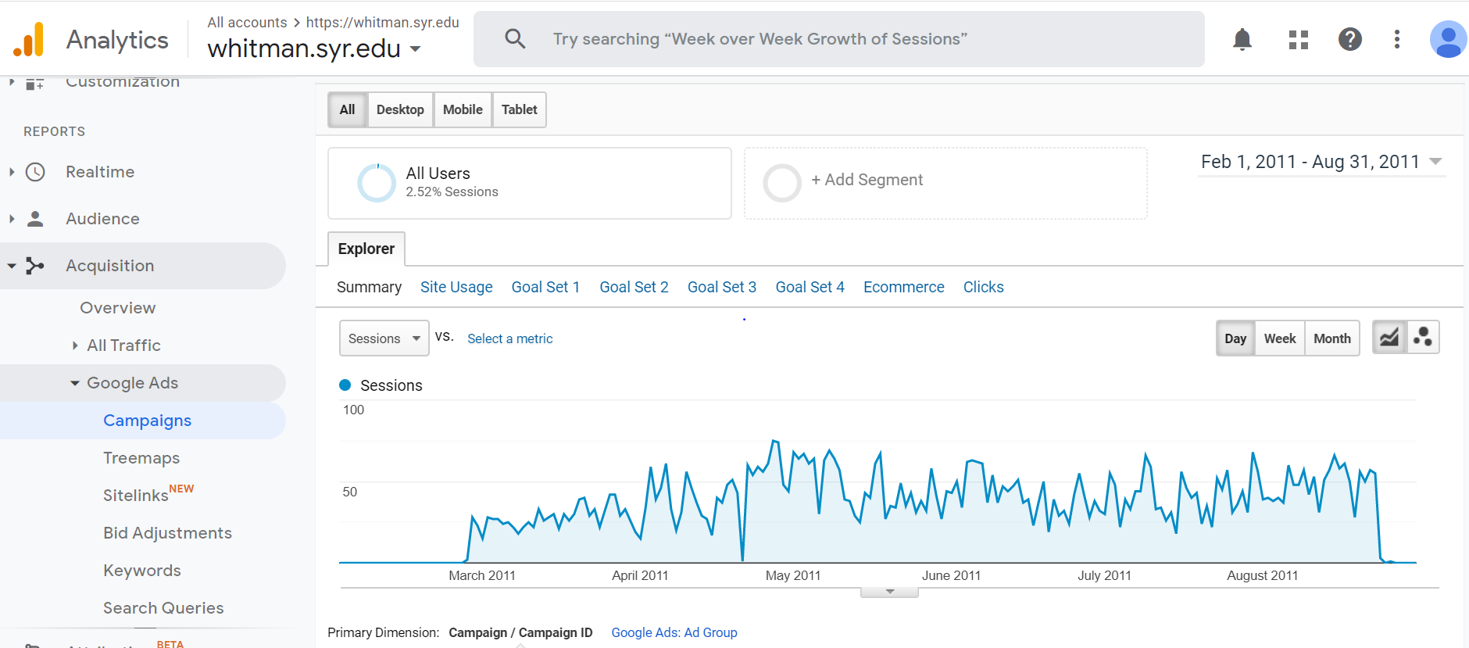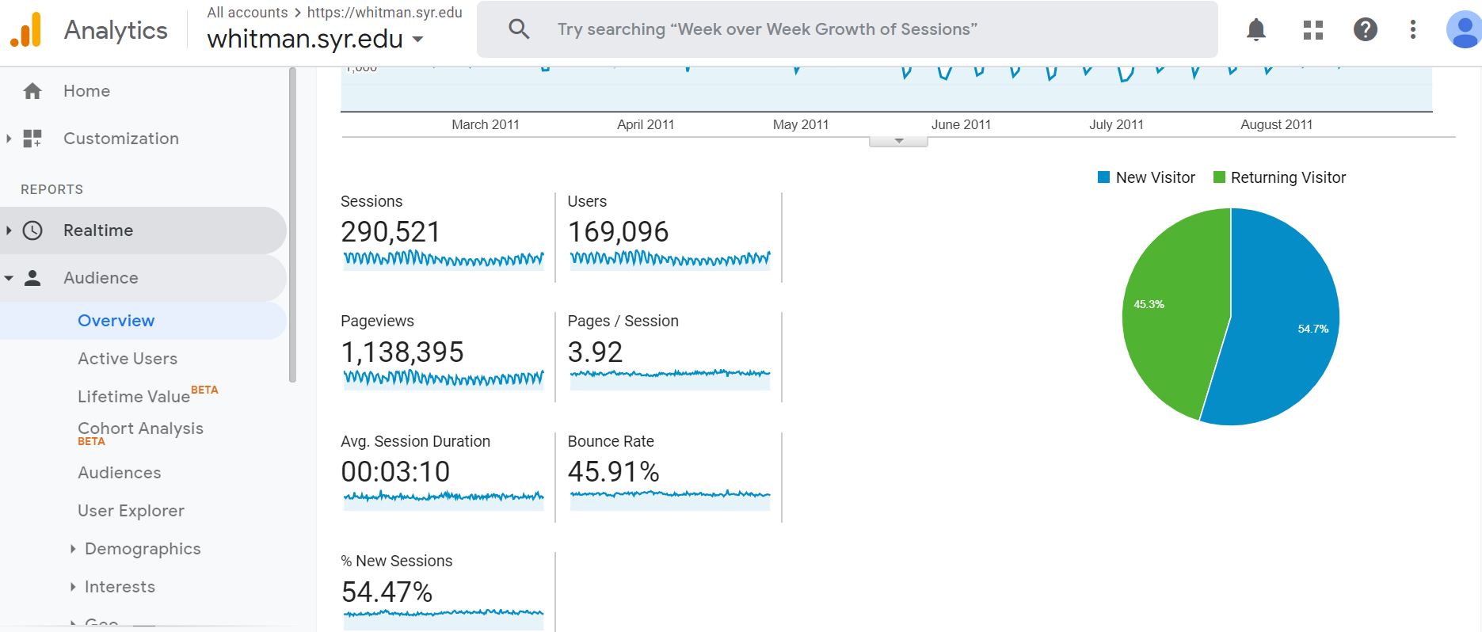

Chart 1 Chart 2

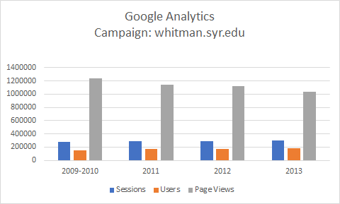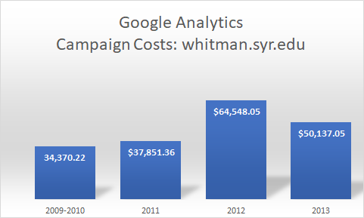

1. MBA Marketing – Full-time

The MBA Marketing Full Time campaign went from October 25th 2012 to July 2nd 2013. The cost for this campaign was $91,717.22 and had a Cost per Click of $8.38. The cost per click remained at this level throughout the campaign. What was specifically interesting was the higher bounce rate compared to some of the other campaigns. This marketing campaign had a higher bounce rate of ~83% as compared to ~46% for the whitman.syr.edu Google Ad campaign. This could be particularly concerning relative to the effectiveness of the campaign. One could infer that the higher bounce rate means that users would not research much further than one page after the initial visit to the site. This is further justified by a lower level of return visitors at a 10.3% rate. There was one previous campaign which could be identified from January 17th 2012 to February 3rd 2012. As a whole, the total cost was $5,205.30 with $3.03 CPC and a bounce rate of 98%. To make this relative the previous campaign was compared to a similar range, October 25h 2012 to November 12th 2012. This comparison brought similar numbers with the campaign cost being $5,710.07 but CPC were significantly more at $16.41 and a bounce rate of 84%. One major difference is that users were down significantly from 1300 in JAN-FEB range to 290 in the OCT to NOV range. In conclusion, this could mean that the JAN-FEB range was much more effective considering the const and users but less effective with the bounce rate comparison.

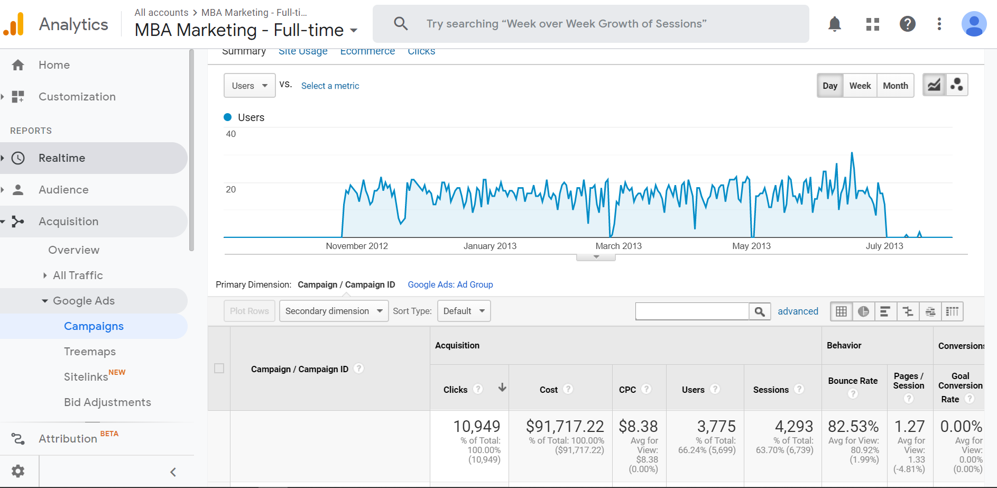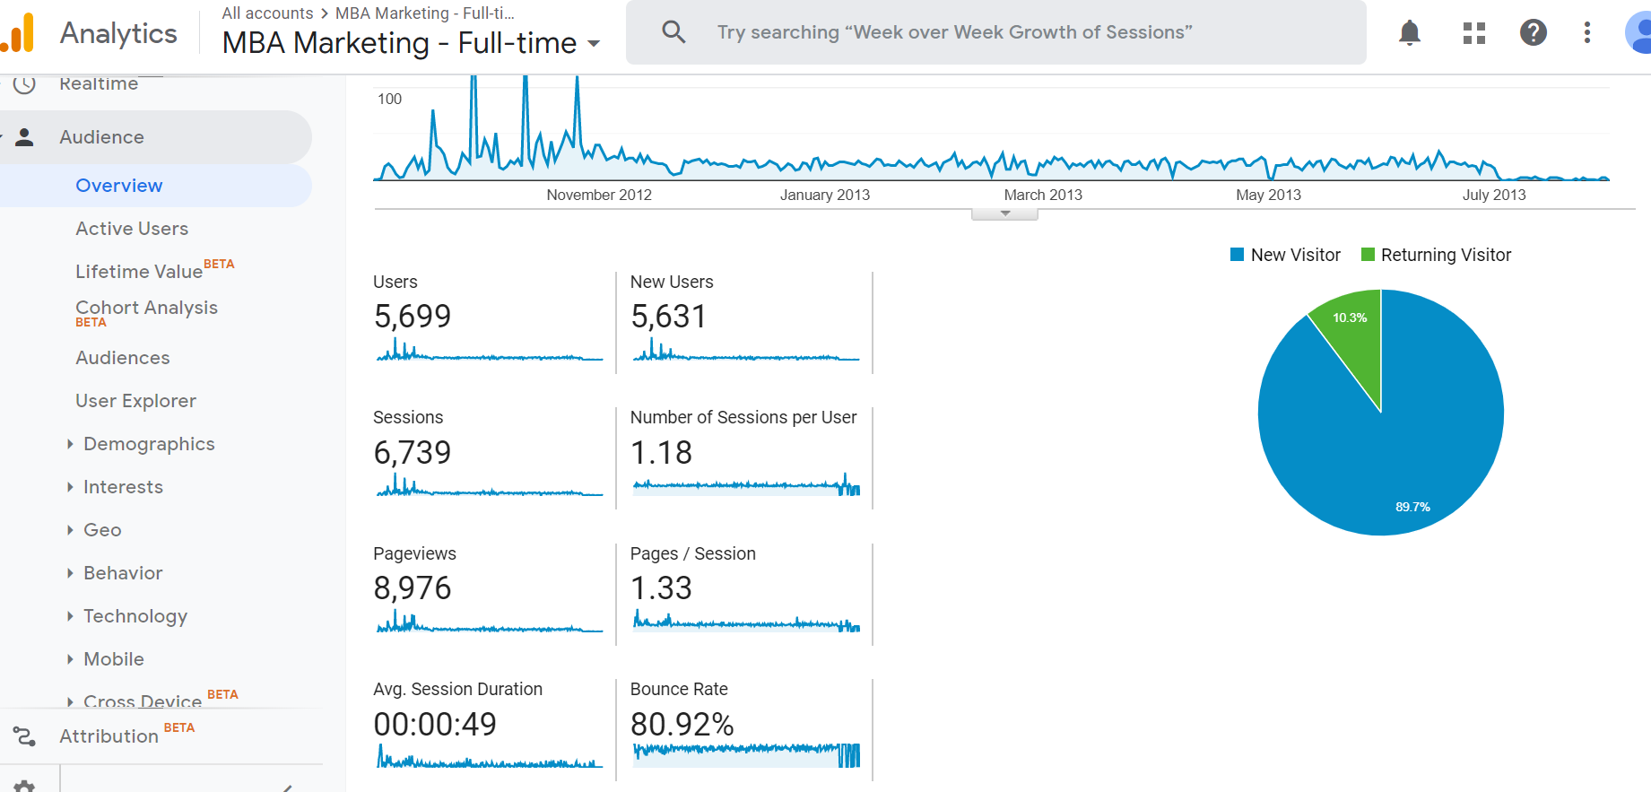

1. MBA Marketing - iMBA

The campaign went from February 11th 2011 to August 29th, 2013. The cost was $204,228. The cost per day started out low in 2011 at around $119, but it eventually spiked up to about $250. There seems to be no users during the 2011 to 2012 time period even if the cost is steady. The campaign had an increasing number of hits throughout 2012. It shows the number of users increasing to an average of 17 users a day at the end of 2013. This could be a seasonal effect since we do see a higher number of users in at the end of 2012 as well. We also see that even though the Whitman FT MBA Ad Group had a cost of $37,699, in the end it had almost the same amount of clicks as the Whit MBA Display campaign. The most effective and cost-friendly campaign is the Whit MBA Display as it only costs $0.87 per click but it also has gotten the most clicks per cost. Overall, the bounce rate is close to 90% which is lower than whitman.syr.edu campaign. Therefore, the campaign is not one we should explore any further.

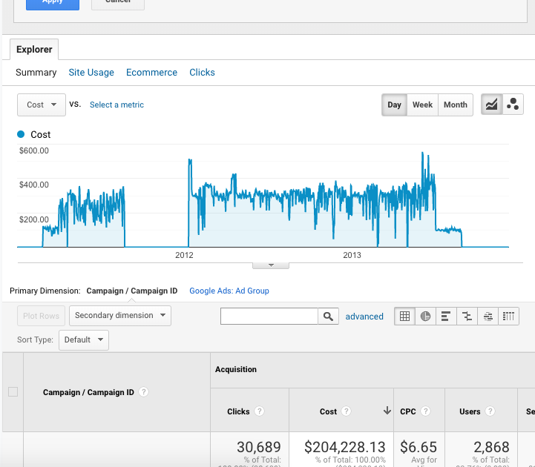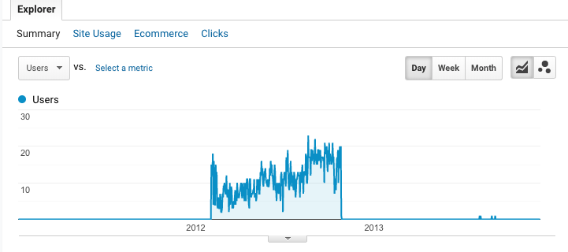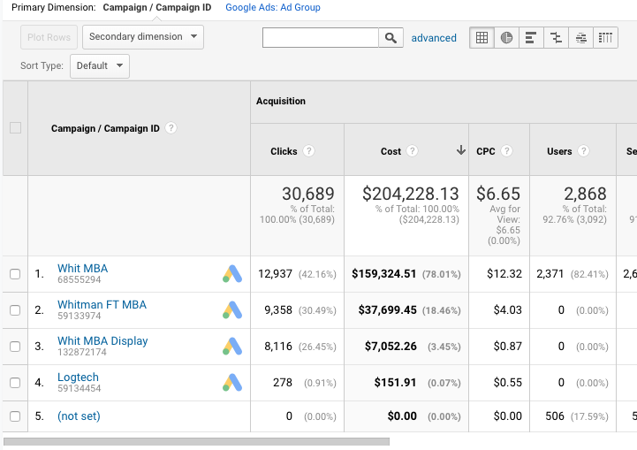

1. Delta

The Delta Campaign was not the most successful one out of the four. It lasted from July 16th, 2013 to November 14th, 2013. There is a significant decrease of activity from July 18th to September 22nd. It almost looks as if the three days in July were used as a trial run or the number of hits was close to zero in this time period. The campaign has only about an average of 2 sessions per day. The magazines in the Delta airplanes in the campaign page, there does not appear anything about the cost. All of the Columns under Conversions add to zero. For example, the total number of conversions is 0. On the other hand, the average session duration is about five minutes and 45 seconds which is enough time to explore the page. The total cost of the campaign added up to $10,000. It is substantially less than the rest of the campaigns, and it also did not create a significant pull of users. On the other hand, the bounce rate is 31.82%. This means that the users were not just clicking and going to another website instantly. The users were spending time exploring the page which can lead to more returning users.

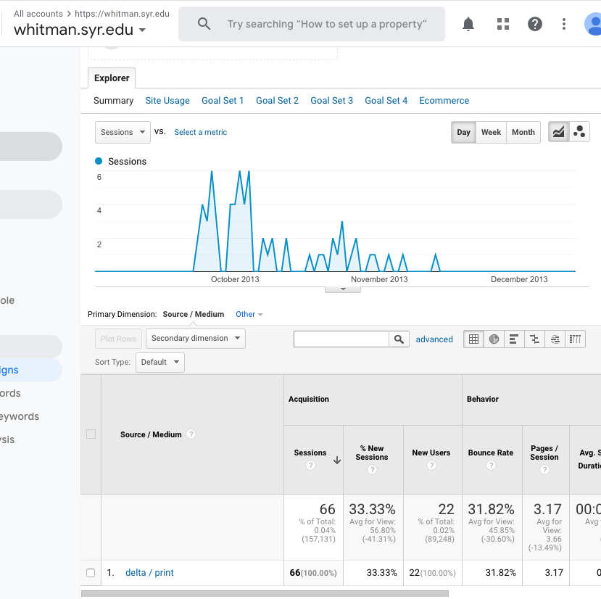

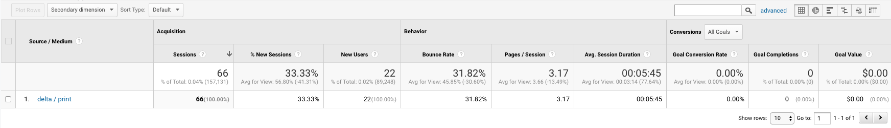

2. Identify the key aspects of a United States campaign for next year (20%)

1. In which geographic region would you advertise? Which states? Why?

New York is the most popular state out of all four campaigns. In some cases, over 30 percent of sessions were from New York state alone. As you can see from the pictures below, New York state has the darkest color on the maps, which indicates it is the most popular state in the United States. Due to the University’s location, it is likely that New York users will continue to come to the website regardless of the advertisement. It may make more sense to focus on the states where we can attract more users. California, Texas and Florida are the alternative states to advertise since those are the second and third most popular states from the all campaigns. The second most popular state was California, which is the strongest candidate to advertise. Except for the Delta campaign, over 10 percent of the sessions were from California. Moreover, Texas and Florida are the one of the biggest states in the United States, if we target those states, then more people will get to know about the campaigns and bring more traffic to the website.

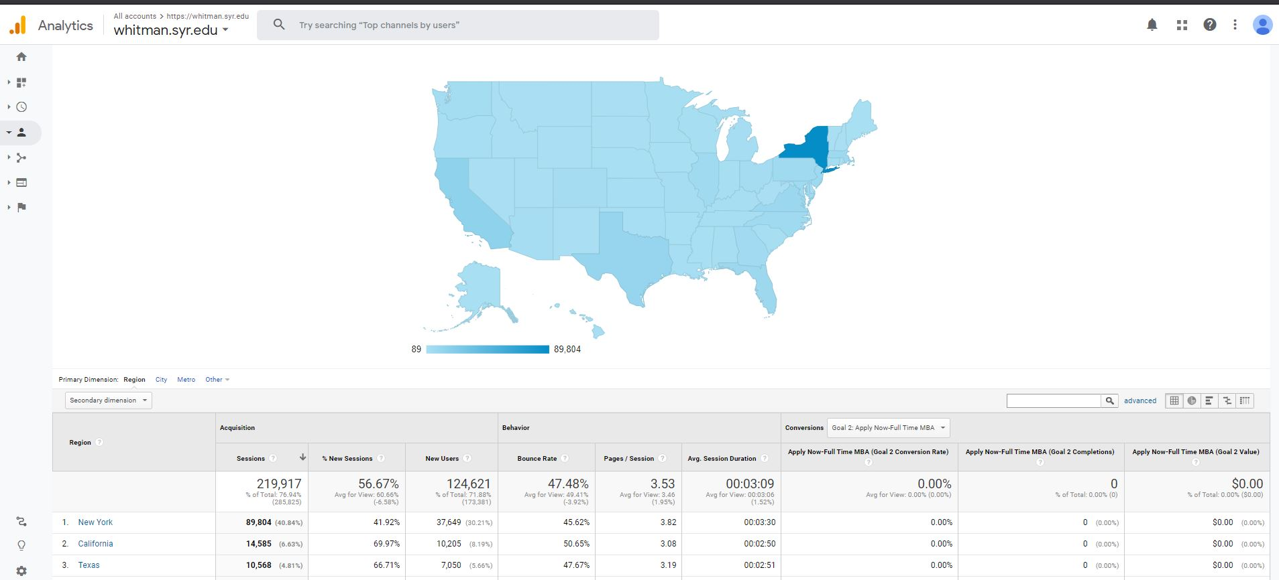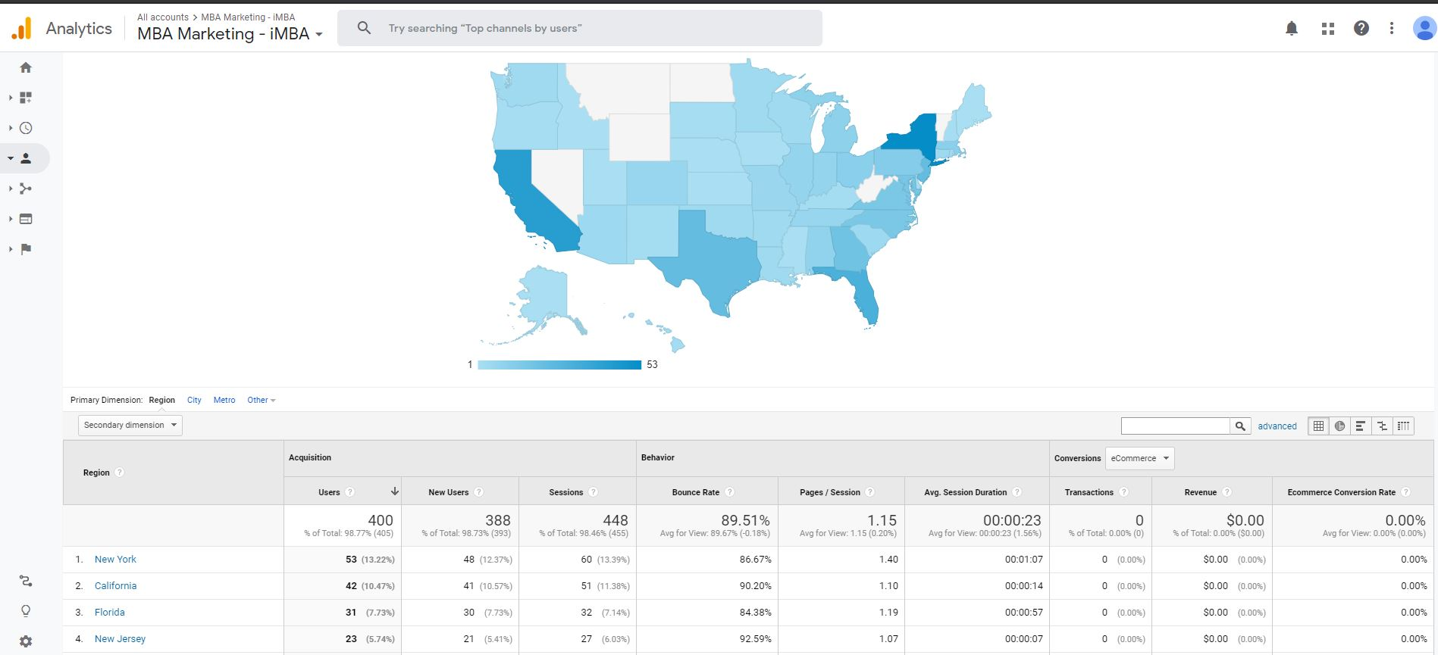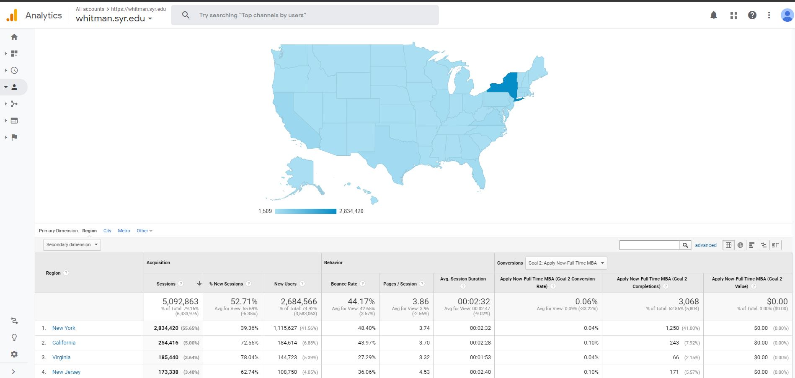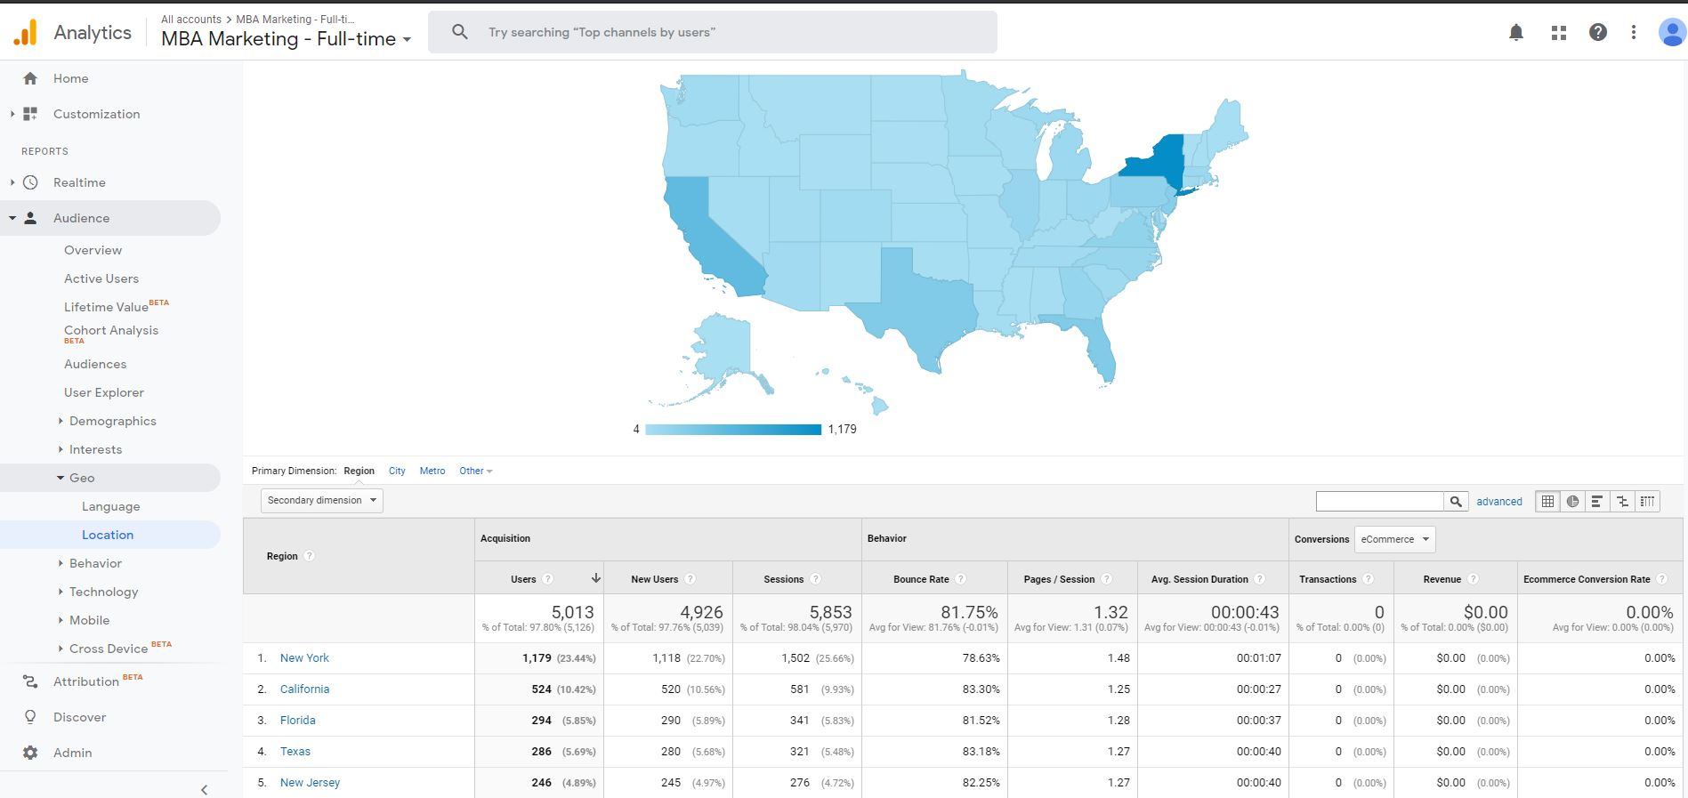

1. What keywords would you use? Why?

The keywords to use are, ‘Online MBA’, ’Whitman School of Management’, ‘Syracuse University MBA’, ‘MBA’, ‘Syracuse MBA’, and ‘Syracuse Online MBA’. These are the keywords that are mostly used to look for all campaigns, especially the keyword, ‘Online MBA’. This keyword brought 80 percent of users to the iMBA campaign back in May 2012. Many users use these terms to look for the campaigns as it is shown below at the chart. For the iMBA campaign, 2004 users alone came with the search ‘online MBA’. MBA Marketing - Full time had the keyword ‘online mba’ as the highest clicks from the GoogleAds keyword search. More than 90 percent of users clicked the online mba to access the campaign. From these results, we should use the top keywords from each category (paid keywords, organic keywords and googleAds keywords) to expose the campaigns for the next year. The top paid keywords are ‘Online MBA’ and ‘MBA’. On the other hand, the top organic search keywords were ‘Syracuse university MBA’ and ‘Syracuse MBA’. Finally, the top google ads search keywords were ‘Online MBA’ and ‘MBA’.

MBA Marketing - iMBA keywords (Paid keywords, organic keywords, and googleAds keywords)

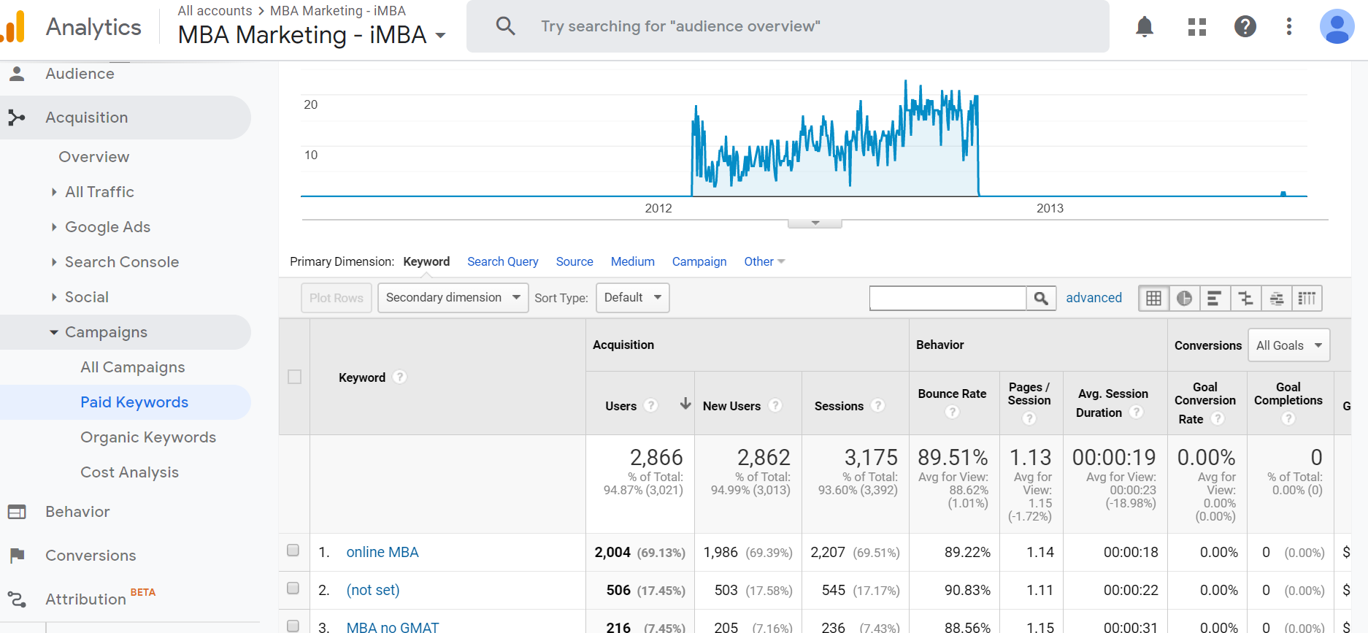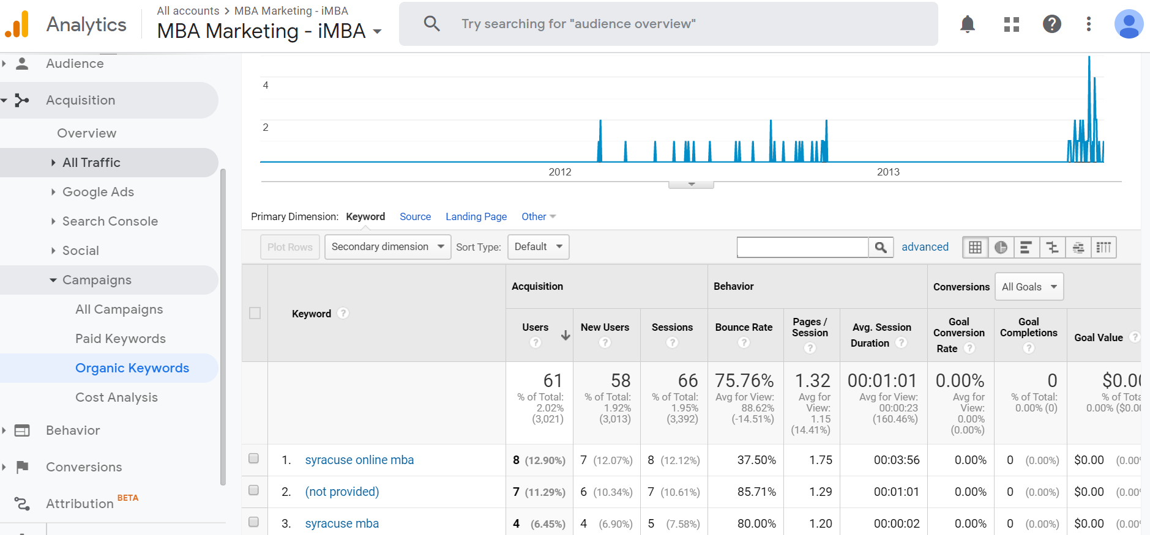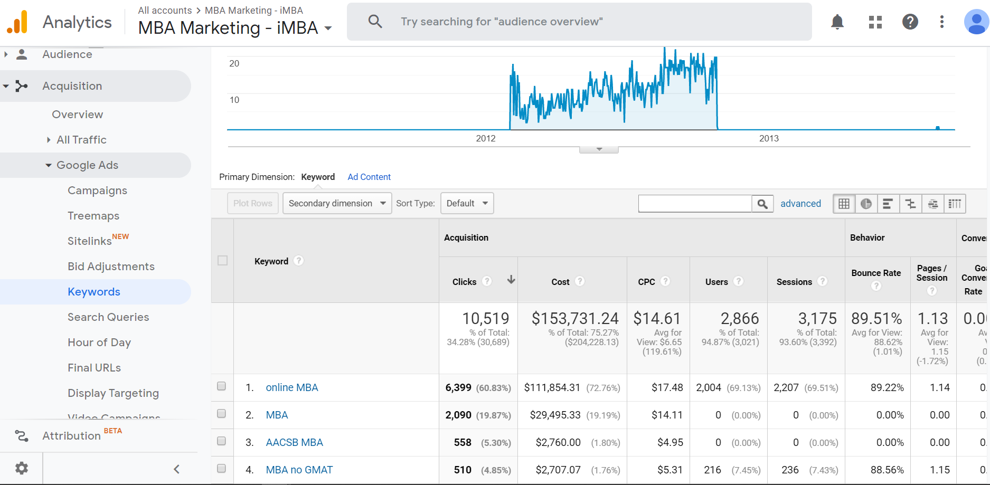

MBA Marketing - Full Time (Paid keywords, organic keywords, and goodAds keywords)

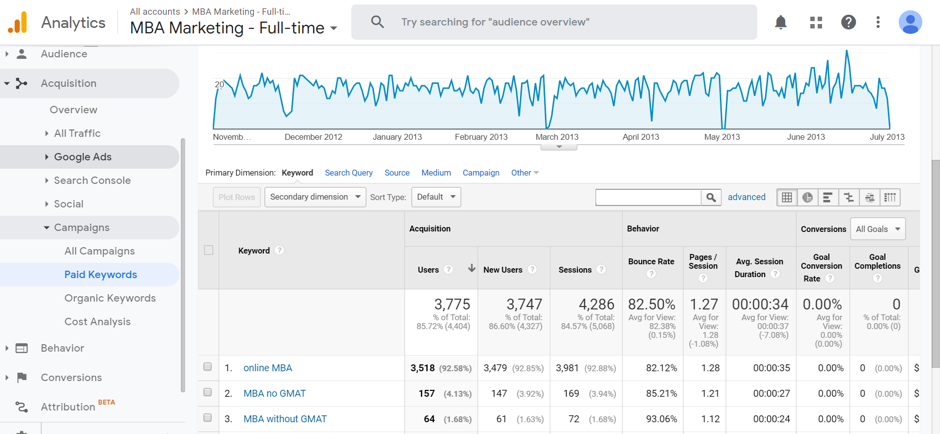

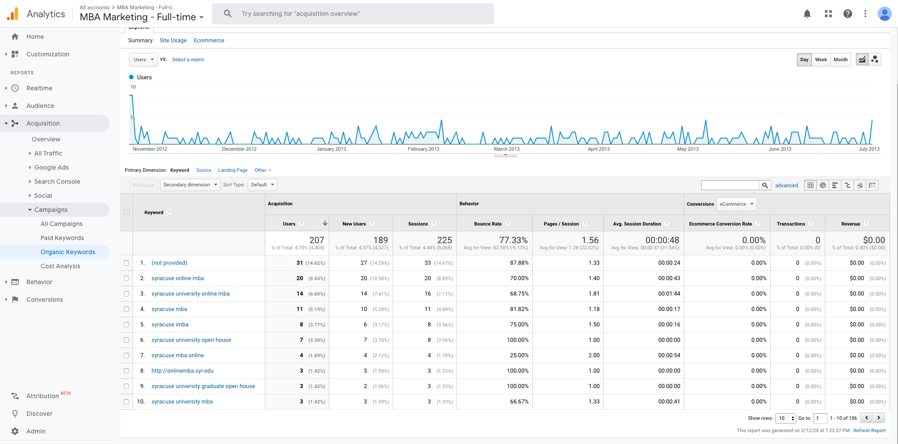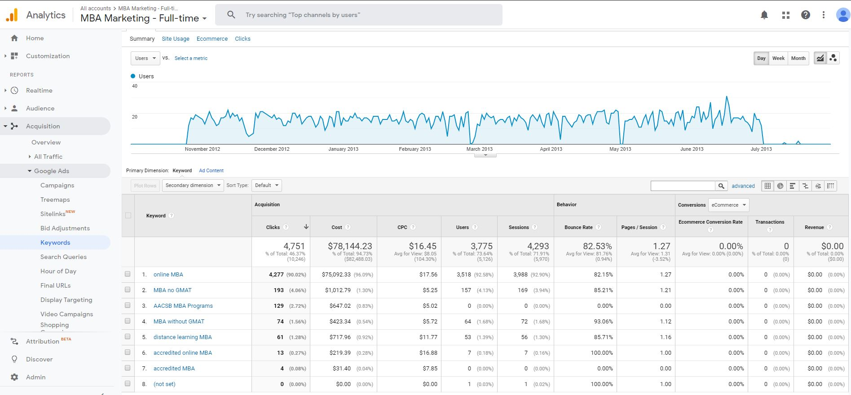

Whitman.syr.edu (Paid keywords, organic keywords, and goodAds keywords)

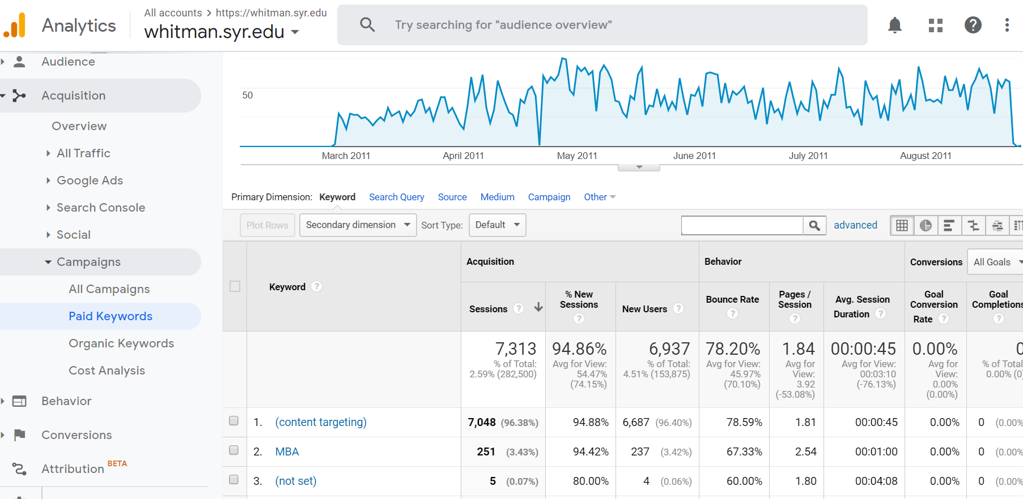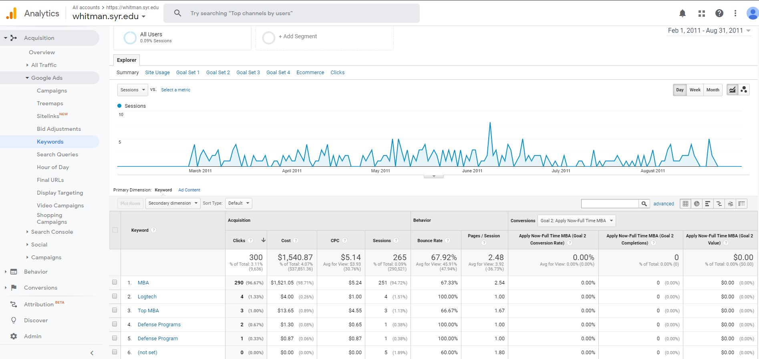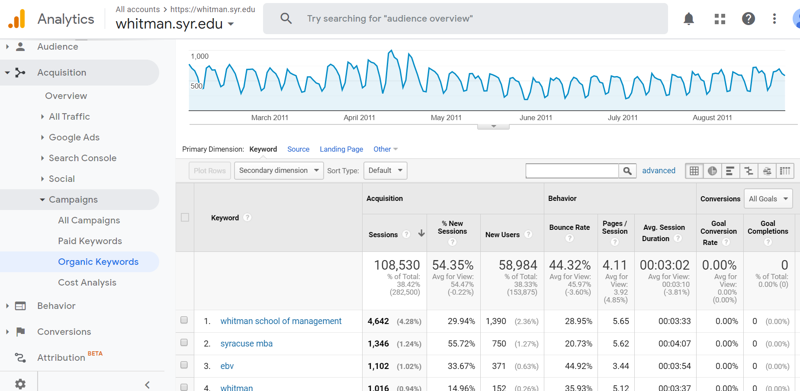

1. Which days of the week and what time of day would you advertise? Why?

The analytics showed that there is more traffic to the website after 1700 PM. More users will see advertisements when they are actively looking for the programs that they are interested in. So It would make more sense to advertise from 1700 PM when people get off work and search for the program. The peak time was 2200 PM, but if we advertise at the peak time, then it would not be efficient to draw more attention to users who are exploring MBA or Online MBA on Google. The day of the week with most activity was Sunday and Saturday. Therefore, we should spend the most on advertisements on the weekends while easing down on Fridays as they show to be the days with the least amount of interaction.

Hours of the day (MBA Marketing - iMBA, MBA Marketing - Full Time, Whitman.syr.edu)

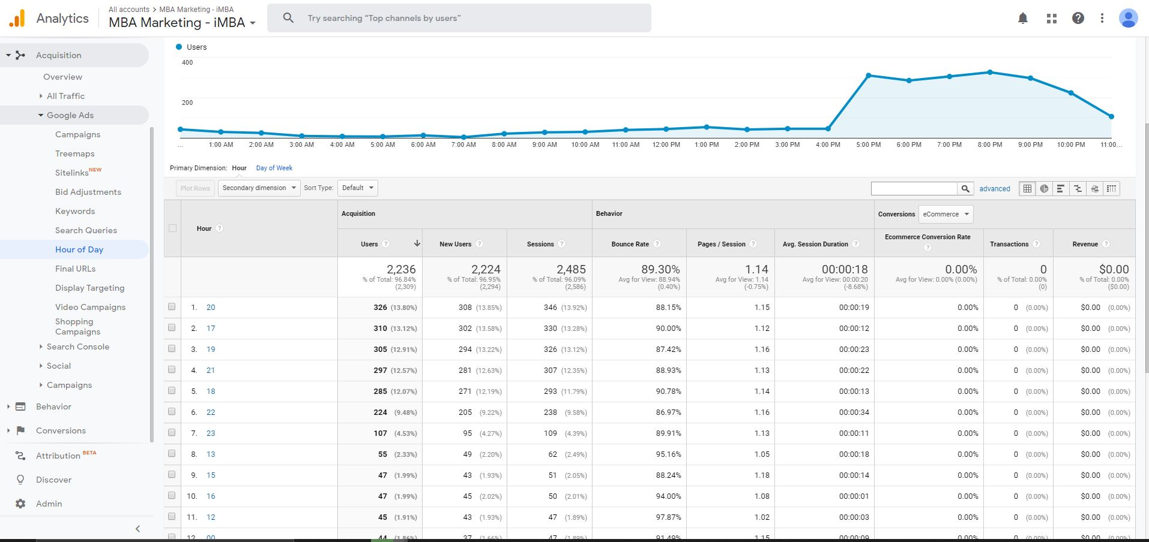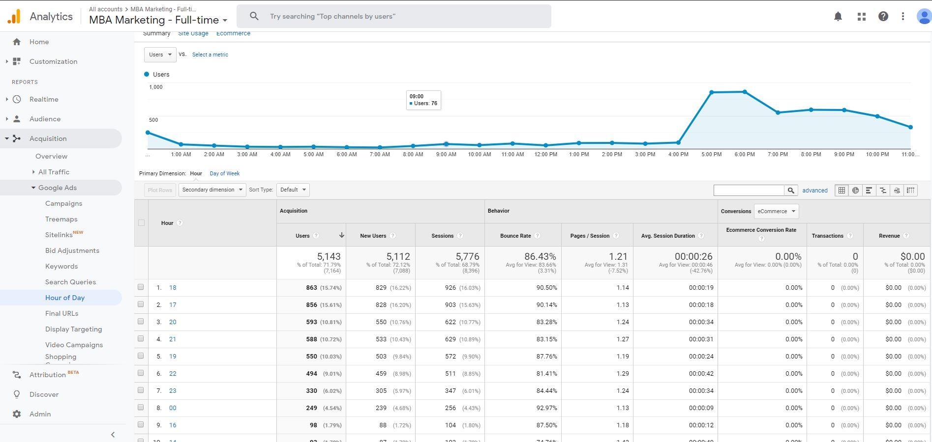

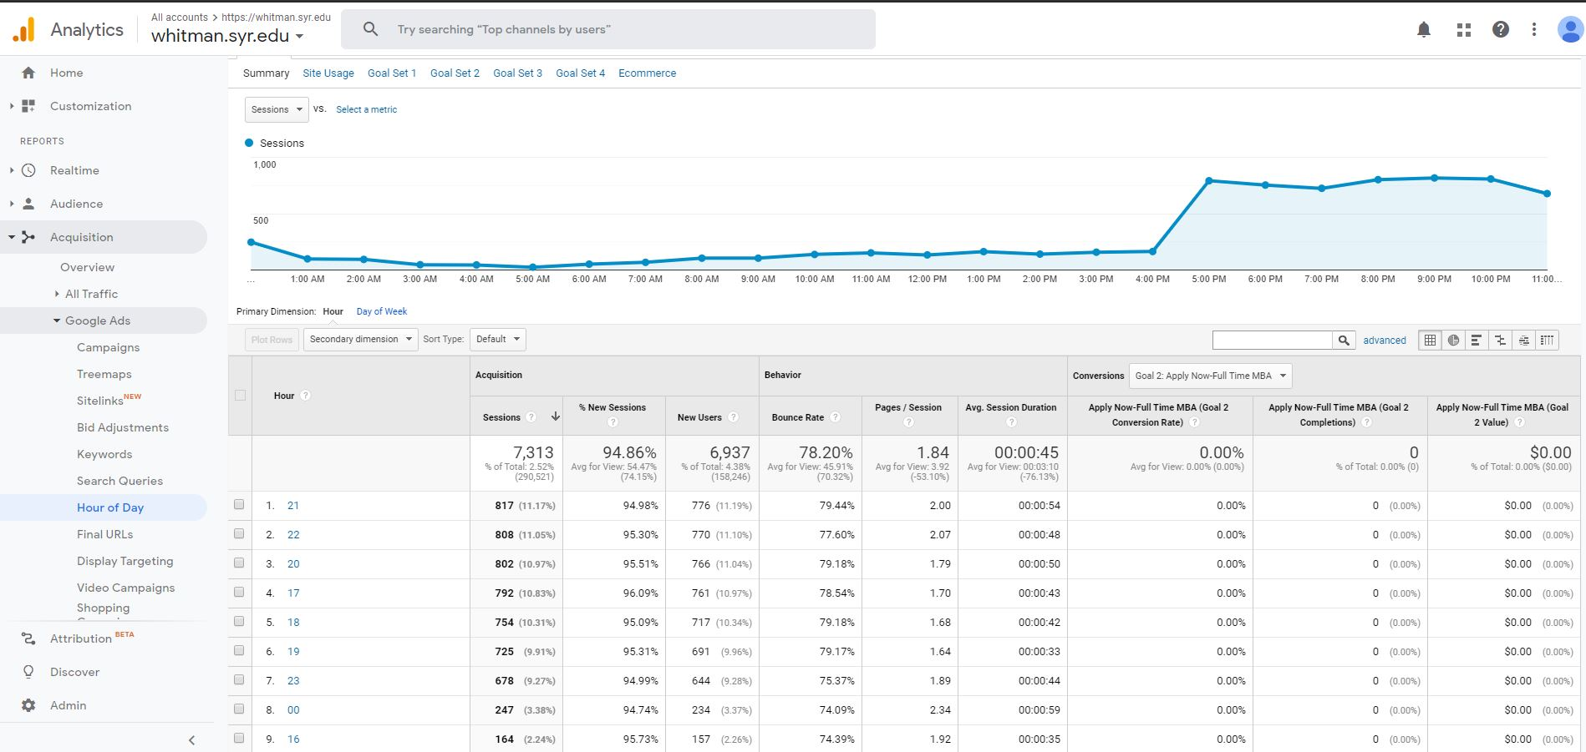

Day of the week (MBA Marketing - iMBA, MBA Marketing - Full Time, Whitman.syr.edu)

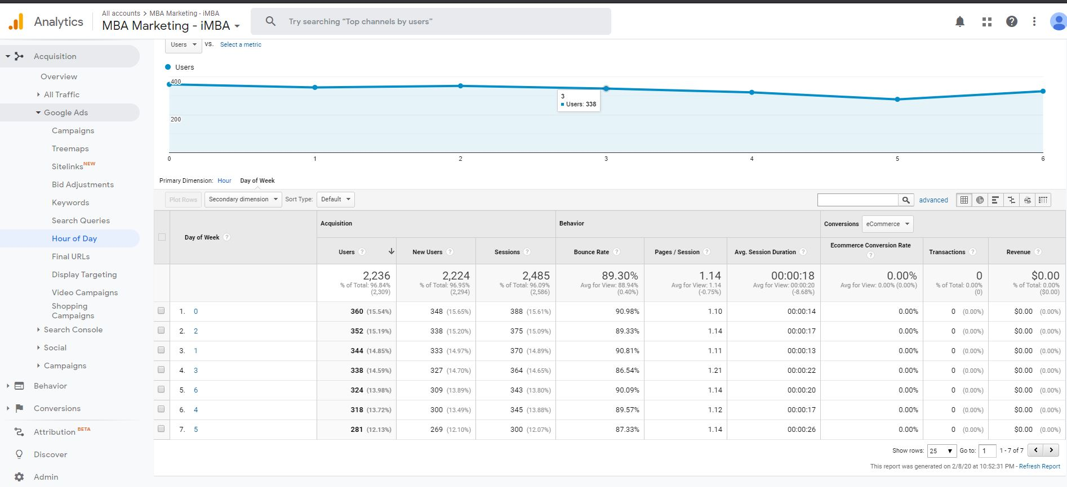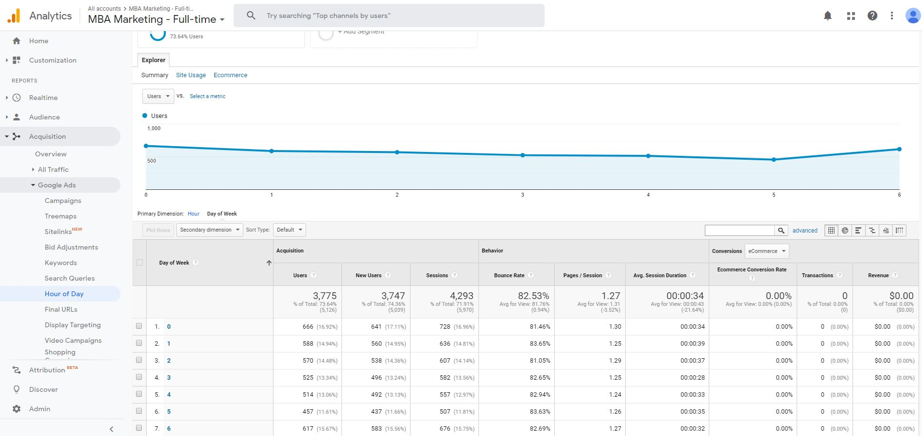

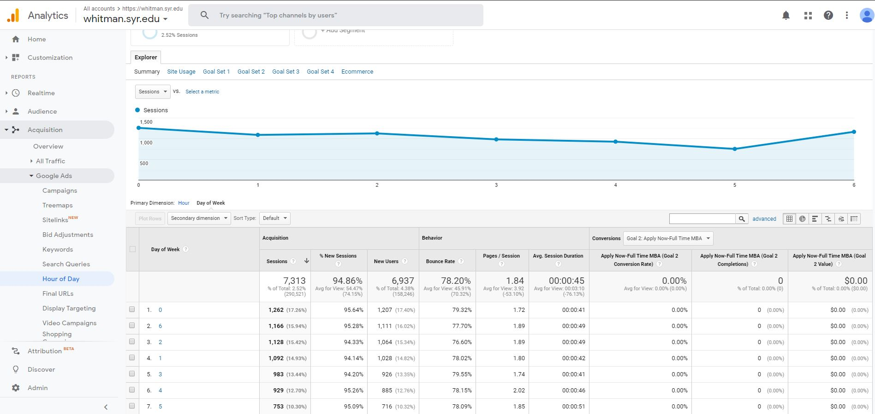

3. Identify the costs for your advertising campaigns (10%)

a. By Region

By region, based on what we found the region that has been the most profitable for this program is the U.S. so we would spend a majority of our budget focusing our advertising in the United States. We decided this because 76.13% of the average total viewer to the whitman.syr.edu site are located in the U.S.; therefore, allowing us to allocate $45,000 to creating more advertisements for our largest base of viewers with a focus on specific states. New York is the most profitable state in the US for Syracuse. New York accounted for up to 30% of site visits during some of the campaigns. In addition, California is the next state that shows the most opportunity for investment as it accounts for 10% of new users in the iMBA campaign. We would first allocate $12,500 to both New York and California. Normally we would choose to focus more on New York than any other state, but as a group we have decided to try to move our marketing focus away from New York in the hopes that we will create more interest across all states. Then, we could evenly split remaining $20,000 to allocate to the most interested states which include Texas, New Jersey and Florida.

As for advertising outside of the United States, we are going to allocate $15,000 to creating advertisements that will be shown in China. This decision comes based on the fact that this region is the second highest percentage of total views to the site. Although China is only 7.01% of the total viewers that are on the whitman.syr.edu site, there is still some interest, and we know this because the region spends on average 00:05:40 on the site which is more than two minutes above the overall average time spent on the site across all regions. Putting more money into the advertising budget for China will allow us to see if this interest continues to grow. As for the rest of our budget we will allocate 5,000 to advertisements in India due to their above average time spent on the site, this interest shows that an increase of advertisements in this region could be profitable. As for the rest of our budget we will break up the remaining budget by allocating to $2,500 to the United Kingdom and the remaining $2,500 to Canada. We chose to continue to advertise to these areas because they do both show interest in the website, however with a less than 1% of the total views to the site we are cautious and only allocating a small amount.

b. By degree program

Splitting up our budget by degree plan is broken down by looking at keywords and understanding what people are searching for in a degree plan. The majority of our budget will be allocated to the online MBA program. The search words “ online MBA” and “MBA” bring more than 75% of the total site views. By allocating resources to these search words we have seen success, so we will continue the projected growth by allocating another $15,000 to the MBA program and the associated keywords such as “online MBA” and “MBA.” This will allow us to continue to reach a consistent base of interested viewers. Although these keywords have been successful in the past with bringing in site traffic, we did find through that the keywords were very similar to the organic searches. Therefore we want to focus our search words and try to allocate advertising to other programs. To do this we will allocate $15,000 to words such as “online Marketing” and “MS Data Analytics”. Both of these words were chosen because they do not directly correlate to the MBA program but instead highlight other Whitman programs. By doing this we will bring more attention to the Whitman site and the other available whitman programs. Along with that we will hopefully bring attention to the new MS program and create more interest.

4. How would you measure the performance of your decisions after implementation? (20%)

With our marketing aim being to continue to reach the New York market, while moving towards a marketing campaign focused in more diverse regions, we definitely expect to see an improvement both in clicks and in bounce rates for users outside of the state of New York. That being said, our measure of success for this campaign should be the number of applications taken versus the dollars spent; both by region and by program.

By re-focusing our advertising efforts to out of state and international regions we are expecting that to get significantly more traffic and time spent on the website from a previously untapped pool of potential candidates. We feel that reaching a broader and underexposed candidate pool will be a more cost effective approach to obtaining more applications. We believe that the incremental cost of converting New York candidates, who are more likely to be familiar with the University and its offerings, will be higher than if we reach new candidates outside the state of New York who are less familiar with the University. We should see an increase of users from states like California and Texas since we have decided to promote the website in a more localized manner. Then, we should also see an increase in interaction from China among other countries where more money will be allocated. By using this smart dispatch of resources will allow us to create a more clever presence in these areas.

Testing this hypothesis is how we will measure the success of the program. By allocating resources to new regions we expect to see a higher application per dollar spent average for our newly focuses regions. Website visits and time spent should be correlated with more applications and we would therefore expect to see more favorable figures for these metrics compared to the prior campaigns. Overall, if our approach is correct we should see an increase in total applications received, which will be the true measure of success.We would also want to see more clicks, smaller bounce rate, and longer sessions from the users. However, if we are spending more money and getting the same proportional number of interactions with the website, then we have failed. The goal of the newest implementation should be to maximizing the website activity while keeping the costs down. Putting more money into advertising will most likely increase the number of users, but the money should not be blindly placed into the same campaigns that were done in previous years.

5. What other factors or considerations are important? What other data would help in developing an Internet advertising strategy, if you could collect it? (10%)

Other factors that we would consider while developing an internet advertising strategy would be looking at undergraduate degree programs and taking into account what programs the perspective students we are actively advertising to have previously taken part in. Along with current jobs students have. With this information we could advertise to people with similar interests and skill sets. It would be easier to understand the analytics if we had background on the percentage of students that are actually from specific regions along with the percentage of students that are in each program.

An important aspect that was noticed is the fact that goals were set for many of the different advertising campaigns but much of the information was left blank, and was not captured by google analytics. We speculated that this may have been a manual input section of google analytics and no one followed through with inputting the data that was collected. Setting goals and being able to track certain parameters would allow us to rely more heavily on google analytics and be more confident in our investments and campaigns. Content targeting was an area that brought many site visitors, but by using content targeting we would want to see what kind of content perspective students are looking at and how google analytics is choosing to advertise based on the perspective students search criteria. This would allow us to refine our paid search words and create an even better advertising plan in the future.

There are a couple other data mechanisms to use which would further develop the advertising strategy. One key piece of data would be to obtain metrics on application and enrollment data. Google analytics provides various levels of user activity and webpage pages visited. In order to understand the success of a particular campaign it would be very beneficial to correlate users who visited multiple webpages and subsequently applied for a MBA program. We could then analyze some of the other data fields based on the user flow through the web pages such as session time, amount of clicks, and returning visitors to see if there are patterns between users who submit an application and have follow on enrollment. For example, maybe there is a correlation between the amount of time spent on a particular page and an application. There may also be a relationship between the amount of clicks by a user or even by a user in a region which produces an enrollment. Without knowing how many students click on the site and become students it is hard to understand how well the campaigns are doing. Additionally, without following that one person from the initial click all the way to their enrollment and particular program of interest.

Another key insight would be how many times one person returns to the site. We cannot currently see if that one person returns multiple times and determine the actual number of singular individuals who are curious in the programs. We may be able to track an IP address relative to a specific region but do not know if that IP address then goes to an application page which would be an overall goal. This analysis flow of data would be even more beneficial if it could tie an enrollment to the university.

Lastly, there were not really any complete results from the Delta campaign. It would be beneficial to see if the magazine developed higher internet traffic (i.e.: more clicks, user sessions, increase of visit based on Delta regions, etc..) which produced more applications. It was unknown if the magazines were on all planes in North America or just pure Delta flights. These magazines may not have made it to the regional carriers which Delta operates but subcontracts. A good portion of the regional flights may have more people who would be interested in researching an MBA versus maybe some of the longer flights. The campaign may have produced an increase in interested people but not knowing more specific about the magazine campaign limits the ability to understand its success.